Day 1: Introduction and Installation

## Introduction

I LOVE Android. I really do. There are more than 1 Billion activations of Android, so building apps for Android that has a potential to reach a billion people should be on top of every developers list. In this series of blog posts, I take that journey of building and Android Application and pushing it all the way to Google Play Store and in the process writing about it.

Welcome to the blog series of “31 days with Xamarin.Android”. In this series I will go over a lot of features of Mobile Application Building of Android apps using Xamarin as technology.

Traditionally we have been building apps the more “silo” approach where teams build an app multiple times with multiple code bases and different toolsets. Which is generally more expensive to build and maintain over the time and not to mention a single change in feature set has also to be duplicated across multiple code bases and teams. [Xamarin](http://xamarin.com/) takes a really impressive approach to build mobile apps where you write code in common language, C#, and Xamarin’s wrappers for Android and iOS take care of converting them into **native** apps for each platform.

With Xamarin you get 100% coverage of native APIs whether it is iOS or Android and Xamarin also has full designer support for Android AXML and iOS Story Board files all while using wonderful language that and its constructs, that is C# and either Visual Studio as IDE. Alternatively, you can also use Xamarin Studio on Mac and the Project and Solution files between the two are interoperable, meaning: you can open the same solution in Visual Studio and Xamarin Studio.

I could go on talking about why picking Xamarin is a smart choice, but that is not why you are here, Dear reader. So let’s get right to why you are here and delve into how to start using Xamarin specifically Xamarin.Android.

## Installation

### Mac:

To install Xamarin on Mac download the [DMG File](http://xamarin.com/download) from Xamarin’s website and go through the installation steps.

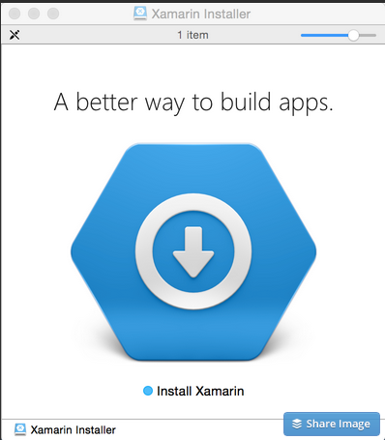

Once all the installation is through you should find a new IDE in your machine called “Xamarin Studio”

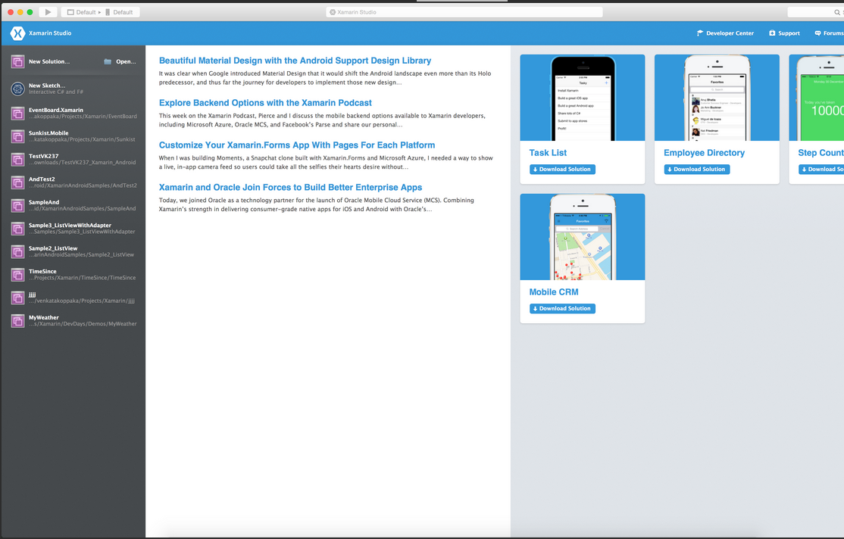

### Windows:

To install Xamarin on Windows download the [EXE File](http://xamarin.com/download) from Xamarin’s website and go through the installation steps.

Xamarin is smart when the installer goes through and installs the Android SDK required for building Android Apps.

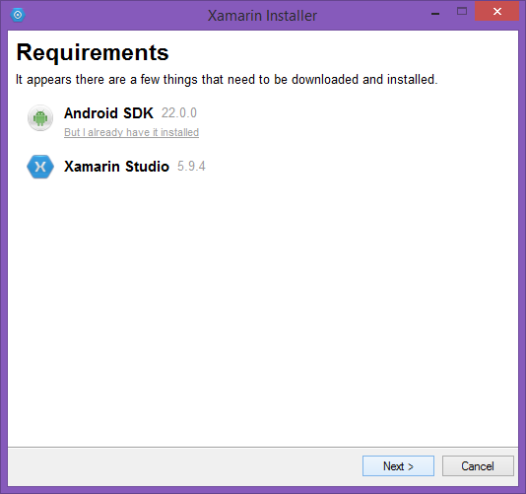

Once the installation is done, if you open up Visual Studio, you should see iOS / Android options under Tools menu.

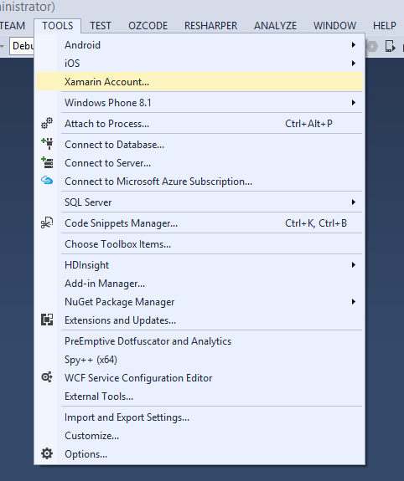

Similar to Mac, Xamarin also installs Xamarin Studio for Windows.

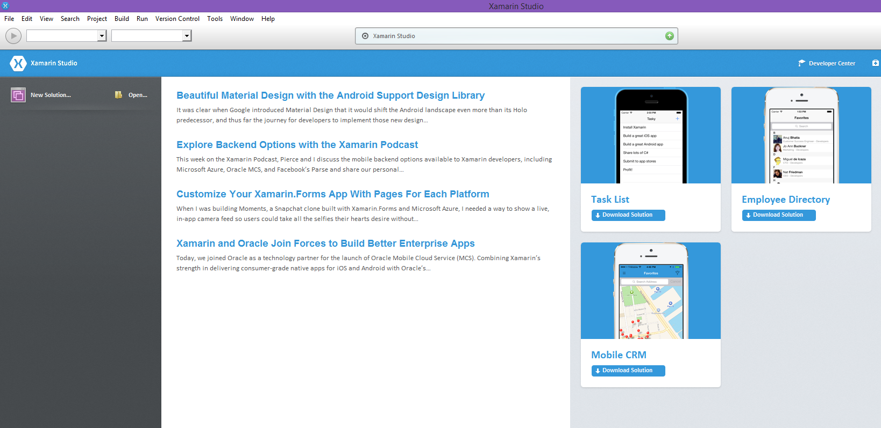

One thing to note is to use Visual Studio with Xamarin you require a Business license of the Xamarin Platform.

That’s it for today. Tomorrow, we will go over different emulators that can be used for Android Development.

Venkata